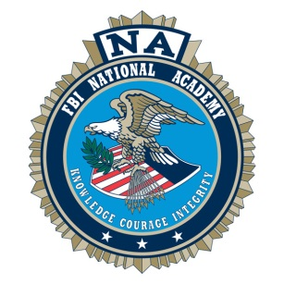
FBINAA HAWAI‘I CHAPTER
2022 Annual Re-Trainer
May 11-13, 2022
Waikoloa Beach Marriott Resort and Spa
Waikoloa, Hawai‘i

**REGISTRATION FORM**

Name:
Last First FBINA Session Year

Rank: Agency: Active
(present or past) Retired

Phone #: ( ) e-mail:

Shirt Size (check one): S M L XL XXL XXXL

*Registrations received after February 18, 2022 will not be guaranteed shirt size requested

*****************************************************************************

DELEGATES | # | REG  FEE | Fee after  3/11/22 | Total $
Hawai‘i Chapter Member (active sworn) |  | $425 | $475
Retired Hawai‘i Chapter or Mainland Chapter Member |  | $275 | $325
Sworn Law Enforcement (Special Delegate –  Non FBINAA Graduates) |  | $450 | $500
DELEGATE GUESTS
Delegate Guests (Meals: Two Breakfasts & Banquet) |  | $250 | $275
May 13th Evening Banquet Dinner Only |  | $105 | $130
 |  |  | TOTAL:
 |  | CHECK #

Activities for spouses and guests to be announced at a later date
******************************************************************************
Please make checks payable to FBINAA Hawai‘i Chapter
Send payment along with registration form by Friday, March 11, 2022, to:

Hawai‘i Police Department
Attention: Major Sherry Bird, Area II Operations
349 Kapi‘olani Street, Hilo, Hawai‘i 96720

Hotel reservations online at: https://book.passkey.com/go/FBINAA2022; or call 1-877-622-3140 and mention to the reservation agent that you are booking a “Passkey Room” under “FBINAA” at the Waikoloa Beach Marriott.

Questions may be directed to Major Sherry Bird, (808)326-4646, ext. 270, or Sherry.Bird@hawaiicounty.gov.

